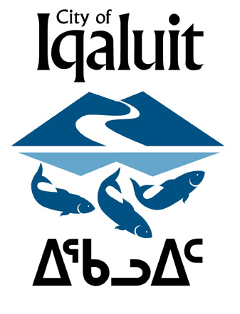

December 20th, 2017

Dear Iqaluit Residents,

The Aquatics Centre is almost ready and we want to hear from you!

The City of Iqaluit Recreation Department is conducting public consultations in preparation for the opening of our new Aquatics Centre in mid-January 2017. In an effort to obtain suggestions, comments and feedback from residents on the types of programs you would like to see at the Aquatic Centre, the City would like to encourage citizens to complete the following survey.

The survey, which will be open until January 10th, 2017, will also be available at the Recreation Reception desk (in the AWG lobby) and in the lobby of the Arnaitok Arena. You can also download a copy from the City website. Completed surveys can be returned to Recreation Reception desk (AWG Arena lobby) or to the drop-box at the Arnaitok Arena.

If you have any questions or concerns please feel free to speak with me in person during the following public consultations or contact me directly at the phone number or email below.
Northmart – Tuesday December 20th 5-6pm
AWG Arena (Family Skate) – Wednesday December 21st 4-5pm
Youth Centre – Wednesday December 21st 5-6pm
Elders Qammaq – Tuesday December 20th 2pm -3pm
Arnaitok Arena (Family Skate) – Thursday December 22 Family Skate 5-6pm

For additional information, please contact Fitness Centre Coordinator Aimee Stoyles by telephone at (867) 979-5617, or by email, a.stoyles@city.iqaluit.nu.ca

